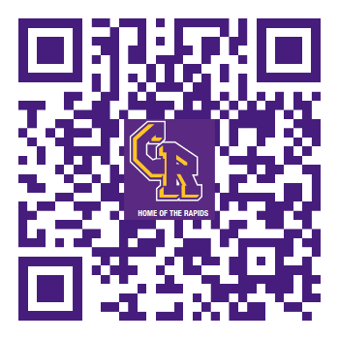
cr boosters
Columbia River High School, 800 NW 99th Street, Vancouver, WA 98665 (360-313-3900)
DISBURSEMENT REQUEST
Please leave in CR Boosters mailbox in CRHS mailroom (checked weekly) or give directly to Treasurer.
***Please be sure CRHS/VPS does not have funds to pay for these items or services BEFORE submitting.***

Submitted By (Print Name): Date:
Email: Group/Club/Sport:
Phone: *Event/Activity/Service:
(*EXAMPLE BUDGET CATEGORIES: Annual Fees/Subscriptions, Awards/Gifts/Prizes, Concessions, Donations, Equipment/Maintenance, Fundraisers, Gear, Grants, Meetings/Food, Travel/Training, Scholarships, etc.)
PURPOSE/DETAILS:

Amount Requested: $
ORIGINAL ITEMIZED RECEIPT(S)/INVOICES MUST BE ATTACHED. (Tape loose receipts on back or separate page.)
CHOOSE ONE: (NOTE: Check directly to vendor is preferred form of payment. Boosters Debit Card is only to be used if checks are not accepted or if a Boosters account has been established.)
Pay by Check - Payment to be made to:
(if different than submitted by)
Deliver Check Via: (CHOOSE ONE)
- I will pick up check. Staff Mailbox at School School Office Directly from Treasurer
Specify Location:
- Mail check to: SEE ATTACHED INVOICE or
Name: Phone:
Address City/State/Zip:
Pay by Debit Card (be sure account info. and contact info./payment instructions are on attached invoice)

COACH/ADVISOR AUTHORIZATION REQUIRED

Coach/Advisor (Print Name/Sign): or attach email w/authorization
Coach/Advisor Phone & Email:
(if different than submitted by)

FOR CR BOOSTERS TREASURER USE ONLY: Entered into MoneyMinder Initials:________
Check #:_________ Check Amount: Same as above or $__________ Date Issued:________________

